SDGs AND PERMACULTURE

Flavia Cardenas
SONED (Southern Networks for Environment and Development)
cardenasflavia@gmail.com

“In this world, things are complicated and are decided by many factors. We should look at problems from different aspects, not from just one.”
-Mao Tse Tung, 1945

Sustainable development and the Sustainable Development Goals (SDGs)

The overall picture of sustainable development is: If we keep doing what we are doing, in the way we live, we do business, and the way we manage the natural resources, we will ruin the planet and societies. Therefore, we need to transform the core elements of our conventional production and consumption patterns (Bachmann, 2016 a, b).

Never before have so many people and world leaders united under one basic idea: Sustainable development. The Agenda 2030 (also known as the Sustainable Development Goals or SDGs) is a framework pointing in the direction we would like this world to develop; is a tool that gives orientation and tells a story about the possibility of a better future allowing us not to see things as they are but as they should be. Because the agenda is globally recognized, it aims to use the experience and skills gained from working in one region or country and transfer knowledge and actions to other locations, while strengthening interdisciplinary research, revitalizing and updating the science-policy interface and re-defining how science (research, teaching, science-based policy advice) can contribute to the societal challenges (Bachmann, 2016 b; Scholz, 2016; Holmgren, 2007).

The Agenda 2030 not only proclaims a different world (change in mind-sets, values, and motivation), but it talks of a different world were different modalities must be imagined and understood as the only way to implement and achieve the identified challenges. The implementation of Agenda 2030 can help to create the strategies that are need for a better future, by placing things in the right place, helping to establish alliances between actors that want the same, and allows networks to develop. It can help us to open our eyes to the possibility of actions in a multi-level and multi-actor playing field, and be a force for positive change that allow us to realize that we have neighbors all over the world and we need to work together (Bachmann, 2016 b; Strandenaes, 2016; Holmgren, 2002).

However, from a scientific point of view, the Agenda 2030 has left much to be desired in terms of its clarity, coherence and ambition (Scholz, 2016). While national governments all over the world are pondering how best to implement SDGs, within societies there are signs of increasing frustration and severe pushbacks from the lack of meaningful progress and unsustainability is becoming deep-rooted in critical aspects of our lives (Bachmann, 2016 a). New approaches are needed to bring stakeholders together. The national and the international levels of stakeholder engagement need to be rethought. Neither one alone is good enough (Bachmann, 2016 b). We need to initiate a worldview change and start to heal communities, ecosystems and the Earth. We must change the approach given to sustainability, a concept from which its guidelines prospered in the last century (Bachmann, 2016 a, b). We have to move beyond learning FROM nature and DESIGN AS nature: search for new ways to restore and maintain ecosystems integrity, safeguard diversity, celebrate cultural diversity and facilitate the transition towards diverse cultures that regenerate not just vital resources and community resilience, but contribute to the health and vitality of nature’s life support systems (Wahl, 2017). As stated by Fukuoka (1978) “Changes, to be of any consequence, must come first at the basic philosophical level.”

Sustainable development
“Development that meets the needs of the present without compromising the ability of future generations to meet their own needs” (Brundtland, 1987)

The focus of the SDGs is on the five Ps: People; Planet; Prosperity; Peace and Partnerships (Strandenaes, 2016)

Why to use permaculture to achieve the SDGs 2030
Too much damage has already been done and sustainable development is not enough. As global citizens we should aspire to build resilient communities and environments that allow us to cope with uncertain futures. We need to restore ecosystem and community health, and create regenerative systems that allow us to face uncertainty creatively (Wahl, 2015). Even those who seem to win in the short-term, in the mid- to long-term will lose if we do not regenerate vital ecosystem functions and create conditions where all of life can thrive (Westaway, personal communication).
Currently, the SDGs implementation is mainly understood as a national responsibility and process. However, when laws and regulations do not resonate with society, little (if anything) will be implemented from a societal level. The SDGs need to be connected to domestic narratives of change, translated into clearer and sharper domestic objectives so that it can reach a much wider audience and increases the society responsibility towards their achievement. Because creating relationships between ideas, knowledge and action is complex, there is a need for tools, procedures and role models that advocate sustainable development and can lead to walk-the-talk realities (Bachmann, 2016 a b; Scholz, 2016; Strandenaes, 2016).

One way of responding to the challenge posed by the SDGs is to grow sustainable development skills that build on knowledge and social competences, on the art of facilitation, and on culture and aesthetics (Bachmann, 2016); empower people to be able to “connect the dots”; use cooperation smartly so that the scarcity of the resources time and money is well used; address the root causes of unsustainable development; re-politicize “the system”; and create self-commitment (Scholz, 2016). Here is where Permaculture becomes an important tool for achieving the SDGs

Permaculture: The right questions can reshape our perception of the world
Current problems faced by humanity, according to Mollison (2009) can be understood as the result of a dependency on external energy for the proper support of the systems (ex. modern agriculture and its dependence on oil). This behavior has created a waste society dependent on a centralized power.

Permaculture is a philosophy based on regional self-sufficiency, worldwide communication and individual responsibility that allows people to understand local and global problems in their most basic form (Mollison, 1979). It accentuates the premise that a successful system does not come from the understanding of the elements that are part of the system, but on the ability to identify how those elements are related and connected to one another, and how by working together they are able to weave synergies and create beneficial relationships improving human lives, ecosystems and planetary health (Wahl, 2017; Willims, 2018). Permaculture uses the holistic principles of system thinking, ecological science, and regenerative design, to create systems that makes sure that everything that can be together is put together, works together, and helps each other to guarantee that all the identified human needs are fulfill (Mollison, 1988).

What characterizes permaculture is its understanding on the ability that each system has to provide the energy it needs for its survival and proper functioning. The systems are arrange in a such a way that energy does not leave before the basic needs are satisfied, guaranteeing that growth, reproduction, and maintenance can continue without any external input (Mollison, 1991). Once the system itself has all the energy it needs to function, and is able to produce more energy than it requires, then it can export or trade energy with/to other systems (Mollison, 2009). Permaculture systems are able to store or conserve more energy than initially was used to construct them or keep them working, a permanent-agriculture and a permanent-culture of self-managed systems (Mollison, 2009).

Systems that are build following the permaculture design principles should last as long as possible, and take low amounts of energy to be maintained. They should produce not only the energy to fulfill their own needs, but the needs of the people that created and control them. Thus, they are sustainable, as they sustain both: themselves and those who construct them. They have less dependence on non- renewable resources and are adapted to use less energy (Rhodes, 2015).

Now a days permaculture is a global – local (glocal) design-based social movement that empowers citizens to change their lives/livelihoods/the world (Westaway, personal communication, February). Using the holistic principles of system thinking, ecological science, and regenerative design, it aims to create solutions for different areas of human lives through pattern observation and site analysis. Using nature as a teacher and emulating as far as possible ecological systems, permaculture allows to discover hidden relationships existing between elements of a natural system, create the conditions for something beneficial to happen, and use proper solutions to face different problems.
Permaculture
“The only ethical decision is to take responsibility for our own existence and that of our children. Make it know” (Mollison, 2009)

The focus of Permaculture Ethics: Earth Care, People Care, and Fair Share
(Strandenaes, 2016)

Objective of the document
Taking into account that keeping the status quo is not working, for achieving the SDGs, it is important to be able to look at the problems with an "open mind", and allow fresh ideas, like Permaculture, to be incorporated.
The aim of this document is to identify those permaculture principles (PP), that allow us to achieve concrete and tangible results related to the proposed 17 SDGs, and show permaculture practitioners that with their daily work, they are already helping to tackle global problems.
Permaculture Principles. How this document understands them
For the purpose of this document, the Permaculture Principles (PP) were divided into three groups:

Universal principles (basic)
1. Observe and interact
8. Integrate rather than segregate
12. Creatively use and respond to change
Attitudinal principles (Bottom-up) | Strategic principles (top to bottom)
2. Catch and store energy  3. Obtain a yield  4. Apply self-regulation and accept feed back  5. Use and value renewable resources and energy  6. Produce no waste | 7. Design from patterns to details  9. Use small and slow solutions  10. Use and value diversity  11. Use edges and value marginal

- Universal principles
The Permaculture Principle (PP) 1, 8 and 12 are understood as the universal permaculture principles for all the 17 SDGs. This means, all of the 17 SDGs are consider to be based on this 3 principles.
Principle 1  Observe and interact | Principle 8  Integrate rather than segregate | Principle 12  Creatively use and respond to change
To be able to develop the SDGs, it was through careful observation and understanding of certain patterns from which the leaders of the world got a better idea of what was happening regarding the economic, social and environmental aspects of human society. From observation, it was possible to acknowledge that if we keep doing what we are doing, in the way we live, we do business, and the way we manage the natural resources, we will ruin the planet and societies. Therefore, is understood that there is a need to intervene now, a need for transformation on the core elements of the conventional production and consumption patterns. (PP1: permaculture designers use careful observation and thoughtful interaction to make more effective use of human capabilities, and reduce dependence on non-renewable energy and high technology (Holmgren, 2007)
Once it was understood there is a need for change, the SDGs came as a framework that points towards the direction the world should develop, allowing us not to see things as they are but as they should be; telling a story about the possibility of a better future, proclaiming the importance of a change of mind-sets, values, and motivation, a different world were different modalities must be imagined, and everyone should be able to creatively respond to change (PP12: Designing to make use of change in a deliberate and cooperative way, and creatively responding or adapting to large scale system change which is beyond our control or influence (Holmgren, 2007).
One of the most important aspects of the SDGs is to understand that to achieve them, things must be placed in the right place, and alliances between actors that want the same thing is crucial, if not mandatory. By working together, the job becomes easier because the different human capabilities are used more effectively. Once there is the realization that everyone has neighbors all over the world, and they need to work together, is possible to open the eyes to the possibility of actions in a multi-level and multi-actor playing field. It is also possible to re-define how science, research, and teaching are key to develop relationships that allows to work together and contribute to achieve societal challenges (PP8: In every aspect of nature, from the internal workings of organisms to the whole ecosystem, we find the connections between things are as important as the things themselves (Holmgren, 2007).

- Attitudinal principles (Bottom-up)
Principle 2  Catch and store energy | Principle 3  Obtain a yield | Principle 4  Apply self-regulation and accept feed back | Principle 5  Use and value renewable resources and energy | Principle 6  Produce no waste
The attitudinal principles are understood as those from the bottom-up. Principles that involve the elements, organisms and individuals of the system. This principles can help to structure social development, create community discussions and participation, are opportunities to learn from, and can give sense of empowerment that comes with knowledge. This principles can be related to concrete actions (know-how) and depend on the attitude of the people and the practitioners (know-who). They can be measure according to the inputs and outputs, and how energy is managed in the system (OCDE, 2001; Jensen et al, 2007; Tonneau & Maurel, 2016).

- Strategic principles (top to bottom)
Principle 7  Design from patterns to details | Principle 9  Use small and slow solutions | Principle 10  Use and value diversity | Principle 11  Use edges and value marginal
The strategic principles, or top-down, are part of the information and design intensive part of the process. They are part of the supporting knowledge that takes an important role on understanding the system (know-why) and making the different pieces work together. They depend mainly on the knowledge available related to needs and capabilities and are part of a “centralized” system that can see the big picture. (OCDE, 2001; Jensen et al, 2007; Tonneau & Maurel, 2016).

The SDGs and the permaculture principles
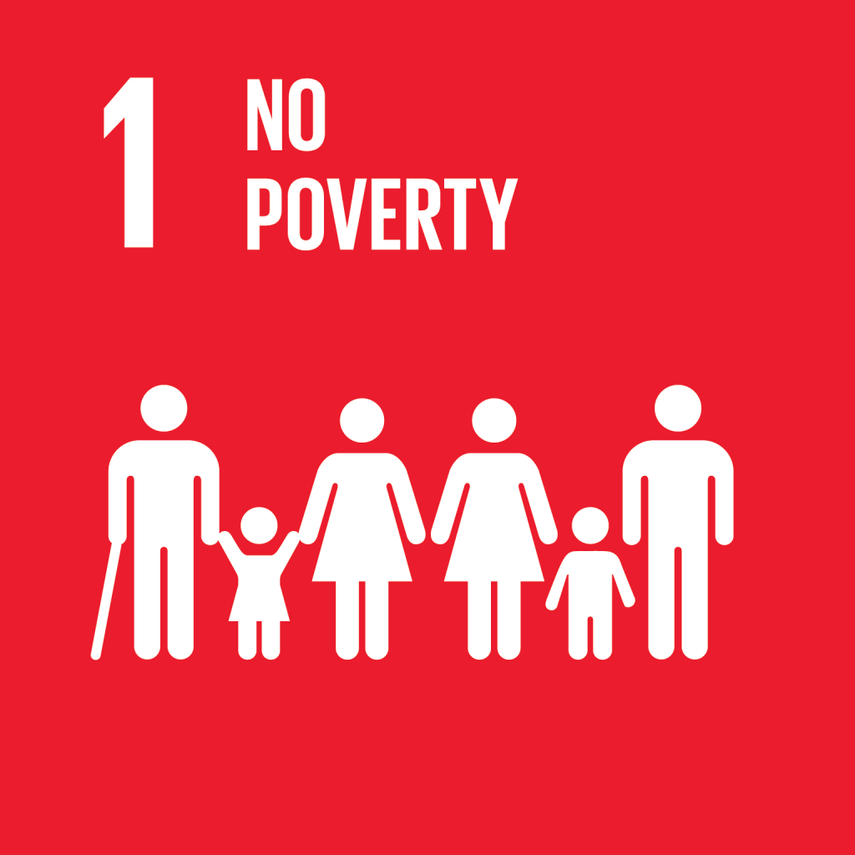 | Goal 1: End poverty in all its forms everywhere
Relevance to permaculture
When people do not have access to natural and economic assets, ownership and control over land, or they are not able to suffice basic services, they are dependent on others to survive. Poverty is the result of an inappropiate way of managing resources and is a sign of dependence. The empowerment of people (also understood as Self-regulation) allows to have strong and independent communities. As stated by Holmgren (2002): A system composed of self-reliant elements is more robust to disturbance and becomes resilient. To deal with poverty, is important to understand the realities and create better solutions according to those realities. Poverty cannot be address in the same way in every part of the word. The reasons why people live in poverty, change from place to place, therefore, the ways to tackle poverty should also be different.
Permaculture Principles
Principle 4  Apply self-regulation and accept feed back | Principle 7  Design from patterns to details

Targets that can be achieve with permaculture
1.4
By 2030, ensure that all men and women, in particular the poor and the vulnerable, have equal rights to economic resources, as well as access to basic services, ownership and control over land and other forms of property, inheritance, natural resources, appropriate new technology and financial services, including microfinance
1.5
By 2030, build the resilience of the poor and those in vulnerable situations and reduce their exposure and vulnerability to climate-related extreme events and other economic, social and environmental shocks and disasters

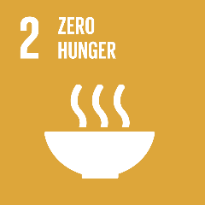 | Goal 2. End hunger, achieve food security and improve nutrition and promote sustainable agriculture
Relevance to permaculture
Permaculture has teach us that by putting the right things in the right place (secure and equal access to land and other productive resources, knowledge, financial services), helps to increase agricultural productivity, as well as the incomes of small-scale food producers. In Permaculture, those systems that most effectively obtain a yield, and use it most effectively to meet the needs of survival, tend to prevail over other alternatives. These systems are characterized for being small and slow solutions that can ensure sustainable food production, the best way to use renewable resources, and maintain yields for longer periods of time. Implementing resilient agricultural practices help to maintain genetic diversity that helps to reduce vulnerability and provides insurance against the vagaries of nature and everyday life.
Permaculture principles
Principle 2  Catch and store energy | Principle 3  Obtain a yield | Principle 5  Use and value renewable resources and energy | Principle 7  Design from patterns to details | Principle 9  Use small and slow solutions

Targets that can be achieve with permaculture
2.1
By 2030, end hunger and ensure access by all people, in particular the poor and people in vulnerable situations, including infants, to safe, nutritious and sufficient food all year round
2.2
By 2030, end all forms of malnutrition, including achieving, by 2025, the internationally agreed targets on stunting and wasting in children under 5 years of age, and address the nutritional needs of adolescent girls, pregnant and lactating women and older persons
2.3
By 2030, double the agricultural productivity and incomes of small-scale food producers, in particular women, indigenous people, family farmers, pastoralists and fishers, including through secure and equal access to land, other productive resources and inputs, knowledge, financial services, markets and opportunities for value addition and non-farm employment
2.4
By 2030, ensure sustainable food production systems and implement resilient agricultural practices that increase productivity and production, that help maintain ecosystems, that strengthen capacity for adaptation to climate change, extreme weather, drought, flooding and other disasters and that progressively improve land and soil quality
2.5
By 2020, maintain the genetic diversity of seeds, cultivated plants and farmed and domesticated animals and their related wild species, including through soundly managed and diversified seed and plant banks at the national, regional and international levels, and promote access to and fair and equitable sharing of benefits arising from the utilization of genetic resources and associated with traditional knowledge, as internationally agreed.

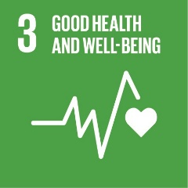 | Goal 3: Ensure healthy lives and promote well-being for all at all ages
Relevance to permaculture
Taking more personal responsibility for our own well-being, is the way in which permaculture relates to this goal. The production of hazardous chemicals in the air, water, soil pollution and contamination (that can cause deaths and illnesses), is the result of our dependence on non-renewable resources. In nature, the out puts of one are the inputs of the other, nothing is waste. Stopping our dependence on non-renewable resources will allow us to have less waste, leading to stop pollution or contamination, that result in a variety of health and spiritual illness.
Permaculture Principles
Principle 5  Use and value renewable resources and energy | Principle 6  Produce no waste

Targets that can be achieve with permaculture
3.9
By 2030, substantially reduce the number of deaths and illnesses from hazardous chemicals and air, water and soil pollution and contamination

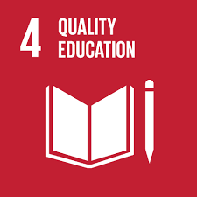 | Goal 4: Ensure inclusive and equitable quality education and promote lifelong learning opportunities for all
Relevance to permaculture:
Redefining what and how we learn, allow us to become more active. Empowering people by using their collective experiences and knowledge can promote sustainable development, allows the system to reduce its vulnerability to a variety of threats and ensure it to attain truly useful rewards as a result to its work. Teaching how to think and have a reflective process of progressive problem solving that enables people to accept their role as a part of the system, encourages people to become more creative and imagine new solutions for the challenges of their surroundings. In this goal, permaculture understand the importance of social capital as an important asset and wealth that is currently being wasted. Collective experience and know how, are a huge store of wealth which can be redeployed to help create new forms of capital. Therefore is critical to give equal access to all women and men, girls and boys to affordable and quality education for developing relevant skills that later on will translate in increasing employment and decent jobs. Valuing and making use of all the resources that are available, assures that there will be more resources that can be used in time of need, the system would not be dependent on external inputs it could produce more sustainable outcomes.
Permaculture Principles
Principle 2  Catch and store energy | Principle 3  Obtain a yield | Principle 4  Apply self-regulation and accept feed back | Principle 10  Use and value diversity

Targets that can be achieve with permaculture
4.3
By 2030, ensure equal access for all women and men to affordable and quality technical, vocational and tertiary education, including university
4.4
By 2030, substantially increase the number of youth and adults who have relevant skills, including technical and vocational skills, for employment, decent jobs and entrepreneurship
4.7
By 2030, ensure that all learners acquire the knowledge and skills needed to promote sustainable development, including, among others, through education for sustainable development and sustainable lifestyles, human rights, gender equality, promotion of a culture of peace and non-violence, global citizenship and appreciation of cultural diversity and of culture’s contribution to sustainable development
4.c
By 2030, substantially increase the supply of qualified teachers, including through international cooperation for teacher training in developing countries, especially least developed countries and small island developing States

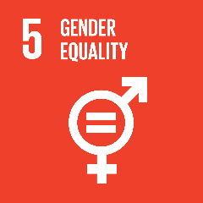 | Goal 5. Achieve gender equality and empower all woman and girls
Relevance to permaculture
In permaculture is important to aim for solutions that can encourage success, growth and replication, and by involving all the individuals in a system, helps to improve diversity, reduce vulnerability and takes advantage of each individual unique nature. Discrimination is an inappropriate activity that does not allow systems to function well. With discrimination, the input made from a large number of individuals is not valued in the system, we are not giving the best use to all the resources available. By giving woman and girls equal rights to economic resources, land, and financial services, we are giving better use to the local wealth (social capital) to achieve more sustainable outcomes. This way we allow the system to get truly rewards from the work that people are doing and attain more that can be used later in times of need. Ensuring women’s full and effective participation and equal opportunities for leadership at all levels of decision making favors the best use of nature’s abundance as using woman as sources of energy that can help to rebuild the social, natural and economic capital. Valuing and making use of all the resources that are available to us, nothing goes to waste.
Permaculture Principles
Principle 2  Catch and store energy | Principle 3  Obtain a yield | Principle 5  Use and value renewable resources and energy | Principle 10  Use and value diversity

Targets that can be achieve with permaculture
5.1
End all forms of discrimination against all women and girls everywhere
5.4
Recognize and value unpaid care and domestic work through the provision of public services, infrastructure and social protection policies and the promotion of shared responsibility within the household and the family as nationally appropriate
5.5
Ensure women’s full and effective participation and equal opportunities for leadership at all levels of decision making in political, economic and public life
5.a
Undertake reforms to give women equal rights to economic resources, as well as access to ownership and control over land and other forms of property, financial services, inheritance and natural resources, in accordance with national laws

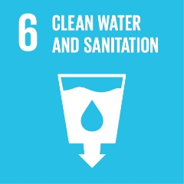 | Goal 6: Ensure availability and sustainable management of water and sanitation for all
Relevance to permaculture:
Permaculture encourages us to give a better use to the renewable resources and use human ingenuity to transform energy from our environment into something more useful. This means that the approach should not only be to maintain what we already have, but to improve it. With water, we should not only protect water bodies and keep water unpolluted and minimizing the amount of hazardous chemicals and materials that are released into it, we should be able to restore water-related ecosystems, recycling the water in a way it could be safe for reuse, or even increase the systems productivity and stability. If everyone takes more personal responsibility, we will be able to reduce water pollution and look for ways that minimize waste of water bodies.
Permaculture Principles
Principle 5  Use and value renewable resources and energy | Principle 6  Produce no waste | Principle 9  Use small and slow solutions | Principle 11  Use edges and value marginal

Targets that can be achieve with permaculture
6.3
By 2030, improve water quality by reducing pollution, eliminating dumping and minimizing release of hazardous chemicals and materials, halving the proportion of untreated wastewater and substantially increasing recycling and safe reuse globally
6.5
By 2030, implement integrated water resources management at all levels, including through transboundary cooperation as appropriate
6.6
By 2020, protect and restore water-related ecosystems, including mountains, forests, wetlands, rivers, aquifers and lakes
6.b
Support and strengthen the participation of local communities in improving water and sanitation management

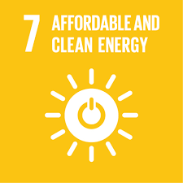 | Goal 7: Ensure access to affordable, reliable, sustainable and modern energy for all
Relevance to permaculture
Current problems faced by humanity can be understood as the result of a dependency on external energy for the proper support of the systems (ex. modern agriculture and its dependence on oil), what has created a waste society. As humanity, we need to use ingenuity to transform energy from our environment into more useful resources. The only way to ensure universal access to affordable, reliable and modern energy for all is by making better use of the existing renewable resources. Permaculture talks about designing small systems that are self-reliant and energy efficient. That means, that while they capture energy, they are able to provide their own energy by using captured and stored energy effectively. Nonrenewable resources should only be used while stablishing the systems, given that by making use of all outputs, pollution and waste are minimized
Permaculture Principles
Principle 2  Catch and store energy | Principle 3  Obtain a yield | Principle 5  Use and value renewable resources and energy | Principle 6  Produce no waste | Principle 9  Use small and slow solutions

Targets that can be achieve with permaculture
7.1
By 2030, ensure universal access to affordable, reliable and modern energy services
7.2
By 2030, increase substantially the share of renewable energy in the global energy mix
7.3
By 2030, double the global rate of improvement in energy efficiency
7.a
By 2030, enhance international cooperation to facilitate access to clean energy research and technology, including renewable energy, energy efficiency and advanced and cleaner fossil-fuel technology, and promote investment in energy infrastructure and clean energy technology
7.b
By 2030, expand infrastructure and upgrade technology for supplying modern and sustainable energy services for all in developing countries, in particular least developed countries, small island developing States and landlocked developing countries, in accordance with their respective programmes of support

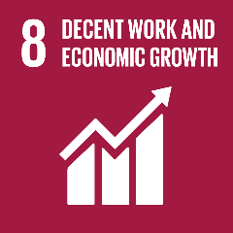 | Goal 8: Promote sustained, inclusive and sustainable economic growth, full and productive employment and decent work for all
Relevance to permaculture
Permaculture highlights the importance of alternative exchange systems for achieving higher levels of economic productivity. Is only through diversification that the systems can reduce their reliance on the current fragile monetary economy system, the most common way to measure growth and wellbeing, but not necessarily the most significant or influential. Aiming towards a sustainable economic growth, has not work properly with keeping the social and natural capital stable. New jobs should be aimed to decouple economic growth from environmental degradation, and renewable resources should be seen as the source of income. Permaculture aims to encourage the creation of systems that effectively obtain a yield, by reinvesting most of the wealth that exists (social economic, natural) and use it to be redeployed to help create new forms of capital (skills, know how, and local technology). Innovation and creativity play a key role not only for the creation of jobs, but also for the the promotion of local culture and products as means of growth.
Permaculture Principles
Principle 2  Catch and store energy | Principle 3  Obtain a yield | Principle 4  Apply self-regulation and accept feed back | Principle 5  Use and value renewable resources and energy | Principle 7  Design from patterns to details

Targets that can be achieve with permaculture
8.2
Achieve higher levels of economic productivity through diversification, technological upgrading and innovation, including through a focus on high-value added and labour-intensive sectors
8.3
Promote development-oriented policies that support productive activities, decent job creation, entrepreneurship, creativity and innovation, and encourage the formalization and growth of micro-, small- and medium-sized enterprises, including through access to financial services
8.4
Improve progressively, through 2030, global resource efficiency in consumption and production and endeavour to decouple economic growth from environmental degradation, in accordance with the 10-Year Framework of Programmes on Sustainable Consumption and Production, with developed countries taking the lead
8.5
By 2030, achieve full and productive employment and decent work for all women and men, including for young people and persons with disabilities, and equal pay for work of equal value
8.6
By 2020, substantially reduce the proportion of youth not in employment, education or training

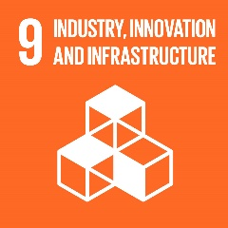 | Goal 9: Build resilient infrastructure, promote inclusive and sustainable industrialization and foster innovation
Relevance to permaculture:
Permaculture looks to develop and use existing infrastructure that can enhance our way of life while minimising long-term impact, because the most common, obvious and popular is not necessarily the most significant or influential, With quality, reliable, sustainable and resilient infrastructure that lasts longer and need less energy input, is possible to support human well-being that can translate in getting truly useful rewards as part of the work that you are doing. Supporting new technologies, research and innovation contribute to the upgrading of infrastructure that makes existing buildings more sustainable and resilient (increased resource-use efficiency and greater adoption of clean and environmentally technologies)
Permaculture Principles
Principle 3  Obtain a yield | Principle 4  Apply self-regulation and accept feed back | Principle 11  Use edges and value marginal

Targets that can be achieve with permaculture
9.1
Develop quality, reliable, sustainable and resilient infrastructure, including regional and transborder infrastructure, to support economic development and human well-being, with a focus on affordable and equitable access for all
9.4
By 2030, upgrade infrastructure and retrofit industries to make them sustainable, with increased resource-use efficiency and greater adoption of clean and environmentally sound technologies and industrial processes, with all countries taking action in accordance with their respective capabilities
9.b
Support domestic technology development, research and innovation in developing countries, including by ensuring a conducive policy environment for, inter alia, industrial diversification and value addition to commodities

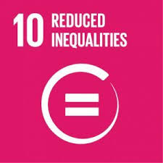 | Goal 10: Reduce inequality within and among countries
Relevance to permaculture:
To reduce inequality among and within contries, it is stated the importance of achieving and sustaining income growth from the bottom part of the population. However, the inappropriate concept of wealth had lead to ignore opportunities to capture different forms of energy to improve community’s lives. In permaculture, is important to understand that there are alternative sources of energy that can be understood as wealth, like the collective experiences, know how, and technology from communities, which are the ones that will help to reduce inequalities. Reorganizing the different types of wealth can later on help to create new forms of capital. For permaculture, more significant than achieving income growth, is to make the elements of the systems self-reliant and energy efficient. By empowering and including different people with different believes, backgrounds, orientations, is possible to view the landscape and communities in new ways. Inclusion can be understood as a tool that uses the diversity existing in the communities to create balance between variety and possibility on the one hand, and productivity and power on the other. But the only way to achieve this is by ensuring equal opportunity and eliminating discriminatory laws, policies and practices
Permaculture Principles
Principle 2  Catch and store energy | Principle 4  Apply self-regulation and accept feed back | Principle 5  Use and value renewable resources and energy | Principle 7  Design from patterns to details | Principle 10  Use and value diversity

Targets that can be achieve with permaculture
10.1
By 2030, progressively achieve and sustain income growth of the bottom 40 per cent of the population at a rate higher than the national average
10.2
By 2030, empower and promote the social, economic and political inclusion of all, irrespective of age, sex, disability, race, ethnicity, origin, religion or economic or other status
10.3
Ensure equal opportunity and reduce inequalities of outcome, including by eliminating discriminatory laws, policies and practices and promoting appropriate legislation, policies and action in this regard

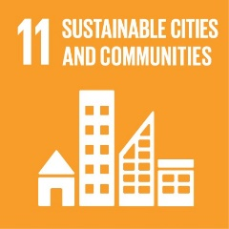 |  | Goal 11. Make cities and human settlements inclusive, safe, resilient, and sustainable
Relevance to permaculture:
Permaculture design aims to create and use infrastructure that can enhance our way of life while minimising long-term impact. By usin the permaculture principles it can be possible to design small settlements in a way that housing, basic services (waste disposal) and transport systems are adequate, and following a sustainble settlement planning with universal access to green and public spaces, the spaces can also be safe, affordable and clean. By empowering people to be self-reliant, they can understand the importance of protecting and safeguarding the world’s cultural and natural heritage elements of the systems, creating knowledge and links between urban, peri-urban and rural.
Permaculture Principles
Principle 4  Apply self-regulation and accept feed back | Principle 6  Produce no waste | Principle 7  Design from patterns to details | Principle 9  Use small and slow solutions | Principle 11  Use edges and value marginal

Targets that can be achieve with permaculture
11.1
By 2030, ensure access for all to adequate, safe and affordable housing and basic services and upgrade slums
11.2
By 2030, provide access to safe, affordable, accessible and sustainable transport systems for all, improving road safety, notably by expanding public transport, with special attention to the needs of those in vulnerable situations, women, children, persons with disabilities and older persons
11.3
By 2030, enhance inclusive and sustainable urbanization and capacity for participatory, integrated and sustainable human settlement planning and management in all countries
11.4
Strengthen efforts to protect and safeguard the world’s cultural and natural heritage
11.5
By 2030, significantly reduce the number of deaths and the number of people affected and substantially decrease the direct economic losses relative to global gross domestic product caused by disasters, including water-related disasters, with a focus on protecting the poor and people in vulnerable situations
11.6
By 2030, reduce the adverse per capita environmental impact of cities, including by paying special attention to air quality and municipal and other waste management
11.7
By 2030, provide universal access to safe, inclusive and accessible, green and public spaces, in particular for women and children, older persons and persons with disabilities
11.a
Support positive economic, social and environmental links between urban, peri-urban and rural areas by strengthening national and regional development planning
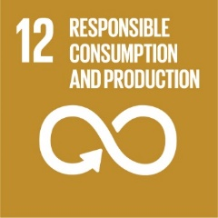 | Goal 12. Ensure sustainable consumption and production patterns
Relevance to permaculture
For this goal, the easiest way to relate with permaculture is by taking more personal responsibility for our own well-being. Is not only about having the relevant information and awareness for sustainable development and lifestyles. Sustainable consumption requires people to give an efficient use of natural resources, minimize the consumptive demands and see renewable resources and waste as sources of income. Find new creative ways to use renewable and nonrenewable resources that not only reduce waste production, but also ways to deal with waste, its transformation and use in creative new sources of capital.
Permaculture Principles
Principle 4  Apply self-regulation and accept feed back | Principle 5  Use and value renewable resources and energy | Principle 6  Produce no waste

Targets that can be achieve with permaculture
12.2
By 2030, achieve the sustainable management and efficient use of natural resources
12.3
By 2030, halve per capita global food waste at the retail and consumer levels and reduce food losses along production and supply chains, including post-harvest losses
12.5
By 2030, substantially reduce waste generation through prevention, reduction, recycling and reuse
12.8
By 2030, ensure that people everywhere have the relevant information and awareness for sustainable development and lifestyles in harmony with nature

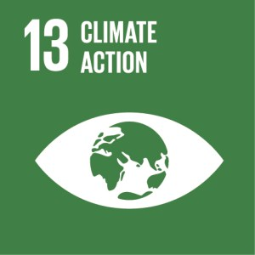 | Goal 13: Take urgent action to combat climate change and its impacts
Relevance to permaculture
Make people, as the main elements of the systems, self-reliant. A system composed of self-reliant elements, is a more robust system to tackle disturbance.
Permaculture Principles
Principle 4
Apply self-regulation and accept feed back

Targets that can be achieve with permaculture
13.1
Strengthen resilience and adaptive capacity to climate related hazards and natural disasters in all countries
13.3
Improve education, awareness-raising and human and institutional capacity on climate change mitigation, adaptation, impact reduction and early warning

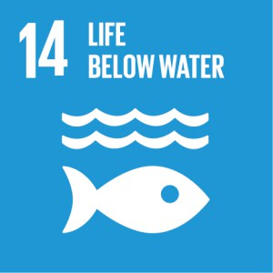 | Goal 14: Conserve and sustainably use the oceans, seas and marine resources for sustainable development
Relevance to permaculture
Permaculture begins by understanding nature, working with her rather than against her. The current practices around fishing are destroying not only the diversity of the oceans, but also the ecosystems ability to capture more energy and become resilient against disaster. Maintaining what we have is not enough. By designing and creating different management plans, we should be able to allow the oceans to become once again self-reliant system that are able to keep providing for themselves. Is important to effectively regulate harvesting; end with, illegal, unreported, unregulated fishing and destructive fishing practices; find ways to minimize pollution and waste that end at the oceans. Only achieving practices that can allow us to keep diversity, we would be able to make the best use of renewable resources and manage and maintain yields and a productive system.
Permaculture Principles
Principle 3  Obtain a yield | Principle 4  Apply self-regulation and accept feed back | Principle 5  Use and value renewable resources and energy | Principle 6  Produce no waste | Principle 10  Use and value diversity

Targets that can be achieve with permaculture
14.1
By 2025, prevent and significantly reduce marine pollution of all kinds, in particular from land-based activities, including marine debris and nutrient pollution
14.2
By 2020, sustainably manage and protect marine and coastal ecosystems to avoid significant adverse impacts, including by strengthening their resilience, and take action for their restoration in order to achieve healthy and productive oceans
14.4
By 2020, effectively regulate harvesting and end overfishing, illegal, unreported and unregulated fishing and destructive fishing practices and implement science-based management plans, in order to restore fish stocks in the shortest time feasible, at least to levels that can produce maximum sustainable yield as determined by their biological characteristics

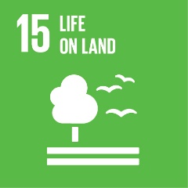 | Goal 15: Protect, restore and promote sustainable use of terrestrial ecosystems, sustainably manage forests, combat desertification, and halt and reverse land degradation and halt biodiversity loss
Relevance to permaculture
Permaculture begins with understanding nature, working with her rather than against her. By giving a good use to renewable resources, we ensure the conservation and sustainable use of terrestrial and inland freshwater ecosystems and their services. However, maintaining what we have and reducing degradation, is not enough. Permaculture allow us to design systems that can restore the land and make the elements of the systems self-reliant and energy efficient. More that conserving, is important to design systems that are able to provide for themselves at all levels, and that are able to use captured and stored energy effectively to maintain the system ability to capture more energy. And to do so, is important to find the appropriate pattern that can help in each ecosystem.
Permaculture Principles
Principle 3  Obtain a yield | Principle 4  Apply self-regulation and accept feed back | Principle 5  Use and value renewable resources and energy | Principle 7  Design from patterns to details | Principle 10  Use and value diversity

Targets that can be achieve with permaculture
15.1
By 2020, ensure the conservation, restoration and sustainable use of terrestrial and inland freshwater ecosystems and their services, in particular forests, wetlands, mountains and drylands, in line with obligations under international agreements
15.2
By 2020, promote the implementation of sustainable management of all types of forests, halt deforestation, restore degraded forests and substantially increase afforestation and reforestation globally
15.3
By 2030, combat desertification, restore degraded land and soil, including land affected by desertification, drought and floods, and strive to achieve a land degradation neutral world
15.4
By 2030, ensure the conservation of mountain ecosystems, including their biodiversity, in order to enhance their capacity to provide benefits that are essential for sustainable development
15.5
Take urgent and significant action to reduce the degradation of natural habitats, halt the loss of biodiversity and, by 2020, protect and prevent the extinction of threatened species
15.6
Promote fair and equitable sharing of the benefits arising from the utilization of genetic resources and promote appropriate access to such resources, as internationally agreed
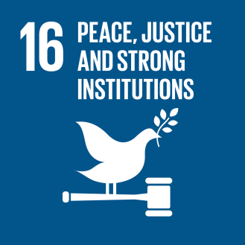 | Goal 16: Promote peaceful and inclusive societies for sustainable development, provide access to justice for all and build effective, accountable and inclusive institutions at all levels
Relevance to permaculture
Principle 4 in permaculture aims to discourage innapropiate activities to ensure that the system is able to work well. Taking the above into account, the only way to reduce corruption and bribery, develop accountable and transparent institutions and ensure responsive, inclusive, participatory and representative decision-making at all levels is by making the elements of the systems self-reliant, what can guarantee that the system is more robust to disturbance.
Permaculture Principles
Principle 4
Apply self-regulation and accept feed back

Targets that can be achieve with permaculture
16.5
Substantially reduce corruption and bribery in all their forms
16.6
Develop effective, accountable and transparent institutions at all levels
16.7
Ensure responsive, inclusive, participatory and representative decision-making at all levels

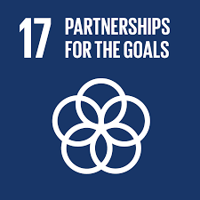 | Goal 17: Strengthen the means of implementation and revitalize the global partnership for sustainable development
Relevance to permaculture
Redifine what we learn, and what type of knowledge we share, allows creativity and hands on movements to flowrish. Permaculture aims that people with different experice share their knowledge and take it to specific situations, and transform it according to the specific needs. North-South, South-South and triangular regional and international cooperation is what make the principles of permaculture stronger, the sharing of ideas and interests. Always starting in a small scale. The knowledge exchange that takes place allows for some level of enhancement regarding sustainable development and the policies related to it.
Permaculture Principles
Principle 4  Apply self-regulation and accept feed back | Principle 7  Design from patterns to details | Principle 9  Use small and slow solutions

Targets that can be achieve with permaculture
17.6
Enhance North-South, South-South and triangular regional and international cooperation on and access to science, technology and innovation and enhance knowledge sharing on mutually agreed terms, including through improved coordination among existing mechanisms, in particular at the United Nations level, and through a global technology facilitation mechanism
17.14
Enhance policy coherence for sustainable development

Permaculture Principles
Principle 1  Observe and interact | Principle 2  Catch and store energy | Principle 3  Obtain a yield | Principle 4  Apply self-regulation and accept feed back
Principle 5  Use and value renewable resources and energy | Principle 6  Produce no waste: | Principle 7  Design from patterns to details | Principle 8  Integrate rather than segregate
Principle 9  Use small and slow solutions | Principle 10  Use and value diversity | Principle 11  Use edges and value marginal | Principle 12  Creatively use and respond to change

References
- Bachmann, G. 2016 a. Introduction: Objectives and spirit of Open SDG club. Berlin. Open SDGclub. Berlin meeting 21 – 23 November 2016, RNE documentation. In https://www.nachhaltigkeitsrat.de/wp- content/uploads/2017/08/RNE_Documentation_Open_SDGclub-Berlin_2016.pdf. Access on March 2018.
- Bachmann, G. 2016 b. The 18th SDG. Sustainable Development in a Changing World: A Changing Perspective on Sustainability. In
https://www.nachhaltigkeitsrat.de/wp-content/uploads/2017/11/Bachmann_Think_Piece_SDG_18_UN_OSD_SDTF_2016-10-27.pdf. Access on March 2018
- Brundtland, G. (1987). Report of the World Commission on Environment and Development: Our Common Future. In http://www.un-documents.net/our-common-future.pdf. Access May 2018.
- Fukuoka, M. 1978. The one-straw revolution: An introduction to natural farming. Emmaus: Rodale Press.
- Holmgren, D. 2002. Permaculture: principles & pathways beyond sustainability. Hepburn, Vic.: Holmgren Design Services.
- Holmgren, D. 2007. Essence of Permaculture. In https://permacultureprinciples.com/wp-content/uploads/2013/02/Essence_of_Pc_EN.pdf . Access in 2018
- Holmgren, D. 2012. Permaculture principles. In https://permacultureprinciples.com/
- Jensen, M. B., Johnson, B., Lorenz, E., & Lundvall, B. Å. 2007. Forms of knowledge and modes of innovation. Research policy, 36(5), 680-693.
- Mollison B (1979) Permaculture two: practical design for town and country in permanent agriculture. Tagari, Tasmania.
- Mollison, B. & Slay, R.M. 1991. Introduction to permaculture. 2nd Edition. Sisters Creek, Tasmania, Australia.
- Mollison, B. 2009. Permaculture: a designer's manual. Second edition
- OCDE. 2001. The DAC Guidelines Strategies for Sustainable Development: Guidance for Development Co-operation. In https://www.oecd.org/dac/environment-development/2669958.pdf
- Rhodes, C. 2015. Permaculture: Regenerative-Not merely sustainable. Energy Balance. November 2, 2015. In http://www.resilience.org/stories/2015-11-02/permaculture-regenerative-not-merely-sustainable/ . Accessed on April 2018.
- Scholz, I. 2016. Non-state actors promoting change towards implementing the UN 2030 Agenda for Sustainable Development. In Foreword: Open SDGclub. Berlin Meeting 21 – 23 November 2016, RNE Documentation. In https://www.nachhaltigkeitsrat.de/wp-content/uploads/2017/08/RNE_Documentation_Open_SDGclub-Berlin_2016.pdf. Access on March 2018
- Strandenaes, J. 2016. The 2030 agenda for sustainable development – w(h)ither its success? In
https://www.nachhaltigkeitsrat.de/wp-content/uploads/2017/11/The_2030_Agenda_-_Whither_its_success_JG_Strandenaes.pdf. Access in April 2018.
- Tonneau, J. P., & Maurel, P. (2017). Satellite imagery: a tool for territorial development. In Land Surface Remote Sensing in Urban and Coastal Areas (pp. 101-139).
- Wahl, D. 2015. Creating sustainability? Join the Re-Generation! The ecologist.com. IN https://theecologist.org/2016/apr/25/creating-sustainability-join-re-generation. 25, April 2016. Access on March 2018
- Wahl, D. 2016. Designing regenerative cultures. Triarchy Press via PublishDrive.
- Wahl, D. 2017. Re-generation. Permaculture. Org.uk. In
https://gaiaeducation.org/wp-content/uploads/2017/11/PM89-Regeneration-pp13-16-1.pdf. Access on March 2018.
- Williams, L. 2018. Permaculture & Sustainability.
IN http://awakenedlifeproject.org/en/about/permaculture-sustainability#. Access on March 2018.

Personal communication
- Duniam, A. 2018. Amatullah Duniam. Permaculture Reseach institute of Europe. Education Coordinator
- Van der Velden, N. 2018. Naomi van der Velden. Permaculture Association. UK
- Warburton-Brown, C. 2018. Chris Warburton-Brown. Research Director of the Permaculture Association. UK
- Westaway, E. 2018. Elizabeth Westaway. Nutrition, NCDs, Agriculture and Livelihoods
- Wood, G. 2018. Graham Wood. Permaculture Association. UK.

Special thanks to the people that help in the development of this document.
- Amatullah Duniam. Permaculture Reseach institute of Europe. Education Coordinator
- Naomi van der Velden. Permaculture Association. UK
- Chris Warburton-Brown. Research Director of the Permaculture Association. UK
- Elizabeth Westaway. Nutrition, NCDs, Agriculture and Livelihoods
- Graham Wood. Permaculture Association. UK.
- Hannah Thorogood. The Inkpot
- Dr. Benjamin Habib. La Trobe University

Energy (input and outputs) in permaculture considers the Odum's ecosystem approach: energy flows, storages, transformations, feedbacks, sinks; incorporates non-living and living elements of the natural environment; and incorporates human systems and economies as an integral part of the natural world (Wood, 2018 personal input).
Art, architecture, agriculture, community planning, cities, enterprises, economics and ecosystem regeneration, climate change, disaster risk reduction, education, energy, food security, health, international development, nutrition, peace building, refugees, sanitation, technology, water.

